**Disaster Recovery Documentation**

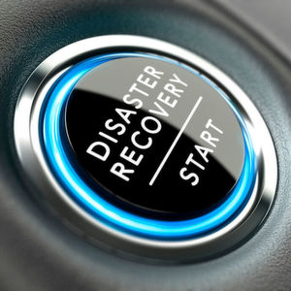

**1. Understanding the Application Setup**

A typical disaster recovery (DR) scenario involves an application setup with the following components:

* **Two instances** (one primary, one secondary) hosting the application.
* **One storage bucket** to store application data, logs, and backups.
* **Frontend**: A user-facing interface such as a website or app.
* **Backend**: Processes logic, database queries, etc.

**2. Immediate Actions in Case of a Disaster**

In the event of a disaster (hardware failure, network outage, or natural disaster), follow these steps:

1. **Identify the failure type**:
   * Check if it’s a system outage, data corruption, or network issue. Use monitoring tools like Prometheus or Datadog.
2. **Failover to the secondary instance**:
   * Using load balancers like AWS Elastic Load Balancer (ELB), traffic can be diverted from the failed instance to the healthy one.
3. **Restore the latest backup**:
   * If data is compromised, restore from the last snapshot stored in the storage bucket (e.g., AWS S3, GCP Storage).
4. **Initiate the recovery process**:
   * Follow the documented recovery steps for the specific failure type (detailed below).

**3. Recovery Methods & Their Efficiencies**

**3.1 Backup and Restore**

* **Description**: Regularly scheduled backups (daily/weekly) stored offsite. Data is restored from backups when needed.
* **Time Complexity**: Slow (can take hours depending on the size).
* **Cost**: Low, but data loss between backups can occur.
* **Use Case**: Non-critical systems.

**3.2 Pilot Light**

* **Description**: A minimal version of the environment (key components) is always running. In case of failure, other parts are quickly deployed.
* **Time Complexity**: Faster than backup/restore but requires manual scaling up.
* **Cost**: Moderate; only the minimal environment is running.
* **Use Case**: Medium-priority applications.

**3.3 Warm Standby**

* **Description**: A scaled-down version of the application is running and ready for fast failover. After a disaster, it is scaled up to full capacity.
* **Time Complexity**: Fast, as the system is partially running.
* **Cost**: Higher than pilot light but ensures quicker recovery.
* **Use Case**: Systems with medium-high criticality.

**3.4 Multi-site Active-Active**

* **Description**: Full-scale environments are running in multiple locations. If one fails, others continue seamlessly.
* **Time Complexity**: Instantaneous failover.
* **Cost**: High due to full replication in multiple locations.
* **Use Case**: Mission-critical applications.

**4. Most Efficient Recovery Method**

**Multi-site Active-Active** is the most efficient method in terms of time complexity. Since there is no downtime, the application can continue running smoothly. Companies like **Google**, **Amazon**, and **Meta** use this approach for their mission-critical systems, ensuring no single point of failure. However, due to its high cost, it’s mainly used for essential applications where downtime would be catastrophic.

For less critical systems, **Warm Standby** offers a good balance between cost and recovery time, making it ideal for most medium-tier applications.

**5. Real-World Examples of Disaster Recovery Strategies**

1. **Amazon (AWS)**:
   * AWS employs **multi-site active-active** for its core services (EC2, S3). AWS’s global infrastructure allows them to replicate data across regions, ensuring high availability.
2. **Google (GCP)**:
   * Google Cloud uses **warm standby** for services like Google Kubernetes Engine (GKE) and **multi-site** for Gmail and Search, allowing automatic failover between regions.
3. **Meta (Facebook)**:
   * Meta uses **multi-site active-active** for its social media platforms, ensuring users face no downtime even during large-scale outages.

**6. Summary**

In a disaster scenario, the goal is to minimize downtime and data loss. While **backup and restore** is a cost-effective approach for non-critical systems, **multi-site active-active** is the go-to for high-availability systems. Choosing the right method depends on your application’s criticality, budget, and recovery time objectives.

By understanding the trade-offs, you can implement the most efficient disaster recovery plan for your infrastructure, much like industry leaders such as Amazon, Google, and Meta.5

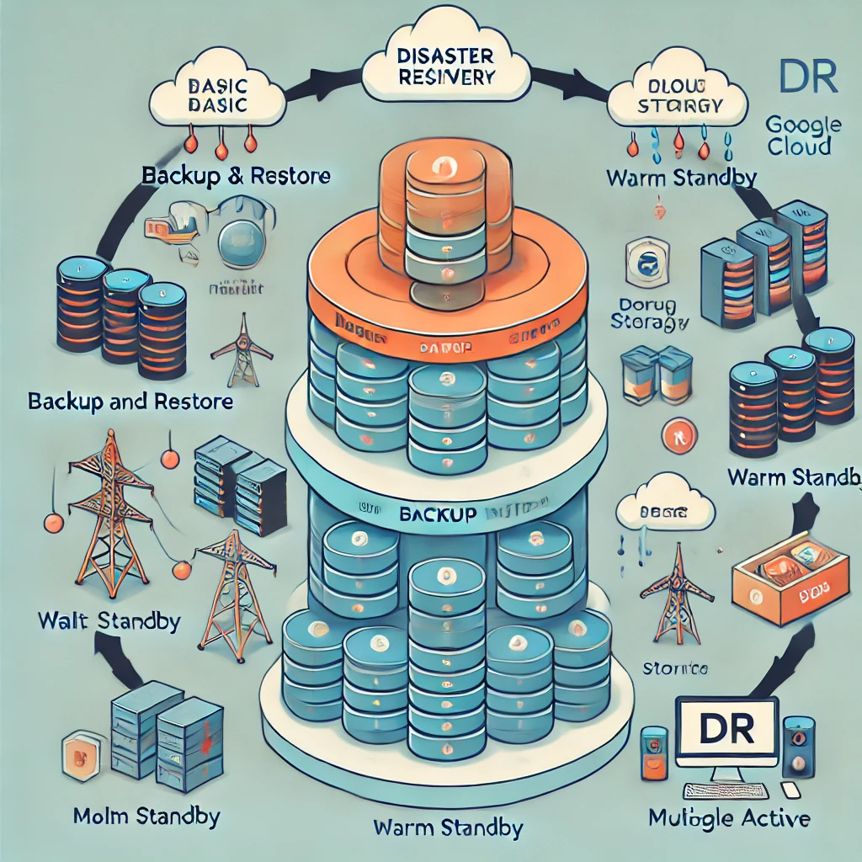

The detailed explanation of Disaster Recovery (DR), along with the image showing the progression from basic to advanced DR strategies:

**1. Basic DR Setup:**

* **Primary Instance**: Main server running the application.
* **Storage Bucket**: Stores backups and critical data.
* **Secondary Instance (Backup)**: Activated in case the primary instance fails.
* **Cloud Storage**: Used for offsite backups (e.g., AWS S3 or GCP Storage).

**2. DR Methods (Step-by-Step):**

* **Backup and Restore**:
  + Data is backed up regularly (daily/weekly).
  + In case of disaster, the data is restored from the latest backup.
  + **Pros**: Low cost.
  + **Cons**: Slow recovery, potential data loss between backups.
* **Pilot Light**:
  + A minimal environment (essential services) is running.
  + In the event of failure, the remaining services are quickly deployed.
  + **Pros**: Faster recovery than backup/restore.
  + **Cons**: Requires some manual intervention.
* **Warm Standby**:
  + A scaled-down version of the entire environment is kept running, ready for quick scaling.
  + **Pros**: Quick recovery with moderate costs.
  + **Cons**: Higher operational cost than pilot light.
* **Multi-site Active-Active**:
  + Full-scale environments run simultaneously in different regions.
  + In case of disaster, traffic is seamlessly rerouted.
  + **Pros**: Instantaneous recovery, no downtime.
  + **Cons**: High cost due to full replication.

**3. Real-life Examples:**

* **Amazon (AWS)**: Uses multi-site active-active for critical services like EC2 and S3.
* **Google Cloud (GCP)**: Employs warm standby and multi-site active-active for high-availability services.
* **Meta**: Ensures no downtime by using multi-site active-active for Facebook and Instagram.

The image illustrates this progression, with each DR method becoming more complex and efficient, from basic backup/restore to advanced multi-site replication.

**1. Scenario 1: Complete Data Center Failure**

You are managing an e-commerce platform running in a single region in AWS. Suddenly, the entire region goes down, affecting all services, including the database, compute instances, and storage.

**Questions**:

* What immediate actions should you take to restore services?
* How would you ensure minimal downtime and data loss using multi-region strategies?
* How would you modify the infrastructure to prevent a similar outage in the future?

**Answers**:

* **Immediate actions**: Failover to another region. If no multi-region setup exists, restore services from backups (S3, RDS snapshots) in another region.
* **Minimal downtime & data loss**: Implement multi-region active-active deployment using AWS Route 53 for DNS failover and global load balancing. Use cross-region replication for databases (RDS/Aurora) and storage (S3).
* **Future prevention**: Shift to a multi-region architecture with active-active setup. Use AWS services like Global Accelerator and Lambda@Edge for faster region failover.

**2. Scenario 2: Data Corruption in Primary Database**

A critical financial application suffers from silent data corruption in the primary database. This was detected after a day, and your team uses hourly backups.

**Questions**:

* What recovery steps would you take to restore the database to a healthy state?
* How can you identify the point of corruption and minimize data loss?
* What long-term solutions would you implement to detect and prevent such issues?

**Answers**:

* **Recovery steps**: Identify the time window of corruption and roll back the database to the last known good snapshot. Restore incremental backups for the most recent data and manually verify the integrity of the restored data.
* **Minimize data loss**: Use tools like AWS Database Migration Service (DMS) or native database tools (e.g., PostgreSQL WAL logs) to trace back and restore the healthy state. Restore from backups prior to the corruption and apply only healthy transaction logs.
* **Long-term solution**: Implement database monitoring tools like AWS RDS Enhanced Monitoring, automated backups with verification, and checksum validation for data integrity. Introduce redundancy and replication strategies with read replicas or active-active database clusters.

**3. Scenario 3: Partial Cloud Outage in a Multi-Cloud Setup**

Your organization is running a critical service using both AWS and GCP. AWS experiences a regional outage, impacting the services hosted there, but GCP is still operational.

**Questions**:

* How do you handle failover from AWS to GCP without disrupting services?
* What cloud-native tools would you use to monitor and manage this multi-cloud setup to ensure high availability?
* How can you optimize costs while maintaining high availability in a multi-cloud architecture?

**Answers**:

* **Failover**: Leverage GCP as a failover by using DNS failover via a multi-cloud load balancer (like Traffic Director or a third-party solution). Sync databases and other stateful services using cross-cloud replication or a tool like Spanner (multi-cloud DB solution).
* **Cloud-native tools**: Use GCP’s Traffic Director and Cloud Operations Suite, combined with AWS Route 53 and CloudWatch for cross-cloud failover monitoring. Employ Terraform or Pulumi for multi-cloud infrastructure as code (IaC) to ensure consistency.
* **Cost optimization**: Use **warm standby** or a **pilot light** approach for GCP, only activating full services in a disaster. Consider hybrid or tiered storage solutions across clouds to reduce costs.

**4. Scenario 4: Security Breach Leading to System Shutdown**

A security breach in your cloud environment (Azure) leads to the shutdown of critical services to contain the attack. The organization is running mission-critical applications that need to be restored immediately after securing the breach.

**Questions**:

* What steps would you follow to safely restore the system while ensuring the attack has been contained?
* How would you implement a disaster recovery plan that includes security-focused recovery methods?
* How do you balance system recovery and security hardening in the aftermath of this breach?

**Answers**:

* **Restoring safely**: First, isolate and remove the infected components (e.g., compromised VMs). Conduct forensic analysis on snapshots and logs. Restore clean backups to fresh, secure instances in Azure and apply security patches.
* **Security-focused DR**: Ensure that backups are encrypted and not compromised. Include security scanning in the recovery workflow (e.g., Azure Security Center). Use security-focused disaster recovery playbooks that include threat hunting, vulnerability scans, and security monitoring (Azure Sentinel, Firewall logs).
* **Balance recovery & security**: Prioritize restoring critical systems using automated, hardened images (e.g., Azure VM scale sets with hardened configurations). Apply zero-trust security models and continue monitoring for suspicious activity during and after recovery.

**5. Scenario 5: Testing DR Strategy with Chaos Engineering**

Your team wants to proactively test the resilience of the current disaster recovery setup by simulating different failure scenarios (e.g., instance failures, network outages) in production using Chaos Engineering.

**Questions**:

* How would you conduct chaos testing in a controlled and safe manner?
* What metrics would you monitor to evaluate the effectiveness of your disaster recovery plan?
* What improvements could you make based on the results of the chaos tests?

**Answers**:

* **Chaos testing**: Use tools like Gremlin or AWS Fault Injection Simulator to simulate controlled failures. Start with low-risk scenarios (e.g., service restarts) and gradually increase complexity (e.g., entire instance failure, network partitions). Always monitor closely and have rollback procedures in place.
* **Metrics to monitor**: RTO and RPO adherence, system performance under stress, failover time, and data consistency. Measure the impact on service uptime, latency, and any unanticipated failure points.
* **Improvements**: Adjust recovery procedures to close gaps found during tests (e.g., slow failover times). Optimize redundancy, auto-scaling, and failover configurations. Consider deploying a more robust multi-cloud or hybrid cloud DR strategy if single points of failure were identified.